
MG2009 – DATA ANALYSIS FOR BUSINESS – II
PROJECT REPORT

Digital Wallet User Behavior and Lifetime Value Analysis

Submitted By:
Aleeha Waseem (24L-5735)
Hajira Tayyib (24L-5583)
Faria Imran (24L-5621)
Aila Zameer (24L-5650)

Submitted To:
Ms. Anum Mahmood

Department of Management Sciences
FAST National University of Computer and Emerging Sciences

Submission Date: April 30, 2026

ABSTRACT
This research project investigates the relationship between age demographics and digital wallet usage behaviour among a sample of 641 users. The study aims to determine whether age group significantly influences preferred payment method and the frequency of total transactions conducted through a mobile wallet application.

We got information on 20 different things from a digital wallet data set that anyone can get to. Then, using SPSS, we did some basic summaries of the data: averages, spreads, how often things happen, breaking figures down into groups, and charts. And to really test our ideas, we used the Chi-Square Test of Independence and One-Way ANOVA (with a 5% margin of error).

Looking at the summary figures, UPI and money already in the wallet are the most popular ways to pay. Gen Z are the biggest daily users of the app. Total Transactions, Total Spent, and Lifetime Value (LTV) all leaned to one side (positive skew) and had some unusually high or low values that weren’t typical. These figures aren't normally distributed. The more detailed tests showed that age doesn't really change which payment method someone prefers (χ²(9) = 3.841, p = 0.922) or how many transactions they make (F(3, 637) = 1.959, p = 0.118). Because we couldn't dismiss the idea that things are equal (the null hypothesis), it looks as though people of all generations are using digital wallets roughly the same way.

ACKNOWLEDGEMENT
We want to thank our teacher from the bottom of our hearts for always being there to help and guide us during this project. The structured project outline from the Department of Management Sciences was very helpful in guiding us through the requirements for statistical research and analysis.
We also thank the publicly available secondary data sources that made our empirical analysis possible. We want to thank our group members for working together, being committed, and being dedicated during the data collection, SPSS analysis, and report writing phases.
This project has helped us a lot to better understand how to use statistical methods in the real world of business.

TABLE OF CONTENTS

1. INTRODUCTION & LITERATURE 1
1.1 Objectives of the Study 2
2. DATA COLLECTION & METHODOLOGY 3
3. ANALYSIS & RESULTS 4
3.1 Descriptive Statistics 4
3.1.1 Frequency Tables 4
3.1.2 Measures of Central Tendency and Dispersion 7
3.1.3 Cross-Tabulation 8
3.1.4 Graphical Analysis 10
3.1.5 Distribution Shape and Normality 13
3.1.6 Outlier Detection 16
3.2 Inferential Statistics 18
3.2.1 Hypothesis 1 – Chi-Square Test 18
3.2.2 Hypothesis 2 – One-Way ANOVA 21
4. CONCLUSION / DISCUSSION 25
5. LIMITATIONS OF THE STUDY 26
REFERENCES 27
APPENDIX 28

LIST OF TABLES
Table 1: Age Group Frequency Distribution
Table 2: Preferred Payment Method Frequency
Table 3: App Usage Frequency Distribution
Table 4: Income Level Frequency Distribution
Table 5: Descriptive Statistics – Central Tendency and Dispersion
Table 6: Cross-Tabulation – Age Group × Preferred Payment Method
Table 7: Cross-Tabulation – Age Group × App Usage Frequency
Table 8: Cross-Tabulation – Age Group × Income Level
Table 9: Tests of Normality (Kolmogorov-Smirnov & Shapiro-Wilk)
Table 10: Summary of Inferential Statistics Results
Table 11: Chi-Square Test – Age Group vs Payment Method
Table 12: One-Way ANOVA – Age Group vs Total Transactions

LIST OF FIGURES

Figure 1: Bar Chart – Age Group vs Preferred Payment Method
Figure 2: Pie Chart – Preferred Payment Method Distribution
Figure 3: Bar Chart – App Usage Frequency by Age Group
Figure 4: Histogram – Age Distribution
Figure 5: Histogram – Total Transactions
Figure 6: Histogram – Total Spent
Figure 7: Line Graph – Average Total Spent by Age Group
Figure 8: Normal Q-Q Plot – Age
Figure 9: Normal Q-Q Plot – Total Transactions
Figure 10: Normal Q-Q Plot – Total Spent
Figure 11: Normal Q-Q Plot – LTV
Figure 12: Boxplot – Total Transactions
Figure 13: Boxplot – Total Spent
Figure 14: Boxplot – Avg Transaction Value
Figure 15: Boxplot – LTV

LIST OF ABBREVIATIONS

Abbreviation | Full Form
SPSS | Statistical Package for the Social Sciences
LTV | Lifetime Value
UPI | Unified Payments Interface
ANOVA | Analysis of Variance
H₀ | Null Hypothesis
H₁ | Alternative Hypothesis
K-S | Kolmogorov-Smirnov
S-W | Shapiro-Wilk
Gen Z | Generation Z (Born 1997–2012)
df | Degrees of Freedom
p | Probability Value (p-value)
α | Level of Significance
DXA | Device-Independent Units (formatting)

1. INTRODUCTION & LITERATURE REVIEW
The rapid spread of smartphones and internet access has changed the global financial landscape in a big way. Digital wallets, which are mobile apps that let people store, send, and receive money electronically, have become the most common way to do business in both developed and developing countries. PayPal, Google Pay, Apple Pay, and other similar services have taken the place of cash and physical debit/credit cards as the main way to pay, especially for younger people.

The digital payments industry has grown very quickly, and the COVID-19 pandemic made it even faster by making contactless transactions and online shopping necessary. Experts in the field say that the global digital payment market will be worth more than a few trillion dollars in transactions in the next few years. This change has sparked a lot of interest in both business and academia in figuring out what makes people use digital wallets more often and for longer periods of time.

Lifetime Value (LTV) is an important number in digital finance. It is the estimated net revenue a business can expect to make from one customer account over the course of the relationship. Businesses can group customers, tailor services, and get the most out of their marketing budgets if they know what demographic and behavioral factors affect LTV. Age is often thought to be one of the most important demographic factors that affect how people use technology and pay for things online.

Previous studies (e.g., Davis, 1989; Venkatesh et al., 2003) have demonstrated that age influences technology acceptance, with younger users exhibiting a heightened propensity to embrace innovative digital tools. However, recent studies indicate that as digital literacy has spread among older generations, the correlation between age and digital payment behavior may be diminishing. This research adds to the ongoing discussion by empirically examining the impact of age group on payment method preference and transaction frequency among digital wallet users.

The present study utilises a secondary dataset of 641 digital wallet users, encompassing variables such as age, income level, preferred payment method, app usage frequency, total transactions, total amount spent, and LTV. Statistical analyses are conducted using SPSS, employing both descriptive and inferential methods.

Research Questions
- Does age group significantly influence the preferred payment method among digital wallet users?
- Does age group significantly affect the total number of transactions conducted via the digital wallet?
- What are the key characteristics of digital wallet users in terms of spending behaviour, transaction volume, and lifetime value?
- Is there a relationship between income level and app usage frequency across different age groups?

1.1 OBJECTIVES OF THE STUDY

- To analyze the demographic distribution of digital wallet users across age groups and income levels.
- To examine the frequency and pattern of preferred payment methods (UPI, Wallet Balance, Debit Card, Credit Card) across age groups.
- To assess the distribution of key behavioral variables: total transactions, total spent, and LTV including normality and outlier assessment.
- To test whether age group significantly influences preferred payment method using the Chi-Square Test of Independence.
- To test whether age group significantly affects total transaction frequency using One-Way ANOVA.
- To draw conclusions and business recommendations based on statistical findings to support digital financial services decision-making.

Hypotheses

Hypothesis 1 (Payment Method):
H₀: There is no significant association between age group and preferred payment method.
H₁: There is a significant association between age group and preferred payment method.

Hypothesis 2 (Transaction Frequency):
H₀: Mean total transactions are equal across all age groups (μ₁ = μ₂ = μ₃ = μ₄).
H₁: At least one age group has a significantly different mean number of total transactions.

2. DATA COLLECTION & METHODOLOGY

2.1 Data Source
This study is based on secondary data obtained from a publicly available digital wallet Lifetime Value (LTV) dataset. The dataset comprises 641 individual customer records collected from a mobile payment application. Secondary data was chosen because it provides a realistic and comprehensive representation of digital wallet user behavior without the logistical constraints associated with primary data collection.

2.2 Variables
The dataset consists of 20 variables. The key variables selected for this study are:

Variable | Type | Description
Age | Continuous | Age of the customer in years (Range: 16–69)
Age_Categories | Categorical (Ordinal) | 1=Gen Z (16–25), 2=Millennials (26–40), 3=Gen X (41–55), 4=Baby Boomers (56–69)
Income_Level | Categorical (Nominal) | Low, Middle, High
Preferred_Payment_Method | Categorical (Nominal) | Credit Card, Debit Card, UPI, Wallet Balance
App_Usage_Frequency | Categorical (Ordinal) | Daily, Weekly, Monthly
Total_Transactions | Continuous | Total number of transactions conducted
Total_Spent | Continuous | Total monetary value of all transactions
Avg_Transaction_Value | Continuous | Average value per transaction
LTV | Continuous | Customer Lifetime Value — projected long-term revenue
Active_Days | Continuous | Number of days the customer has been active
Cashback_Received | Continuous | Total cashback amount received by the user

2.3 Sample Size
The final sample consists of n = 641 valid cases with no missing values across all variables of interest. This sample size is considered adequate for applying both descriptive and inferential statistical analyses, including ANOVA and Chi-Square tests.

2.4 Software
All statistical analyses were conducted using IBM SPSS Statistics. Procedures utilized include Frequencies, Descriptives, Explore, Crosstabs, Chi-Square Test, One-Way ANOVA, and Tests of Normality (Kolmogorov-Smirnov and Shapiro-Wilk).

2.5 Age Categorization
Continuous age values were recoded into four generational categories based on widely accepted demographic classifications:

Category | Age Range | Generation Label | N | Percent
1 | 16–25 | Gen Z | 113 | 17.6%
2 | 26–40 | Millennials | 161 | 25.1%
3 | 41–55 | Gen X | 202 | 31.5%
4 | 56–69 | Baby Boomers | 165 | 25.7%

3. ANALYSIS & RESULTS

3.1 Descriptive Statistics

3.1.1 Frequency Tables

Frequency analysis was conducted for all categorical variables in the dataset. The following tables present frequencies, valid percentages, and cumulative percentages for Age Categories, Preferred Payment Method, App Usage Frequency, and Income Level.

Table 1: Age Group (Age_Categories) Frequency Distribution
Age Category | Label | Frequency | Percent | Valid Percent | Cumulative Percent
1.00 | Gen Z (16–25) | 113 | 17.6% | 17.6% | 17.6%
2.00 | Millennials (26–40) | 161 | 25.1% | 25.1% | 42.7%
3.00 | Gen X (41–55) | 202 | 31.5% | 31.5% | 74.3%
4.00 | Baby Boomers (56–69) | 165 | 25.7% | 25.7% | 100.0%
Total |  | 641 | 100.0% | 100.0%

The majority of participants belong to the Gen X (41–55) category, comprising 31.5% of the sample, followed by Baby Boomers (25.7%) and Millennials (25.1%). Gen Z (16–25) has the smallest representation at 17.6%. This distribution reflects a broad cross-generational sample suitable for comparative age-based analyses of digital payment behavior.

Table 2: Preferred Payment Method (Preferred_Payment_Method) Frequency
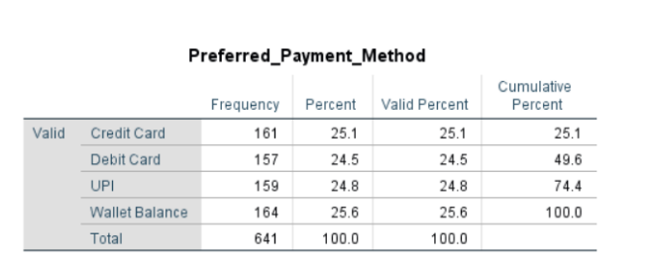
Payment method preferences are distributed almost equally across all four options, with Wallet Balance being the most common (25.6%) and Debit Card the least (24.5%). This near-uniform distribution is notable. It suggests that no single payment method dominates the sample, although combined digital-native methods (UPI + Wallet Balance) account for 50.4% of preferences, slightly outweighing traditional card-based methods.

Table 3: App Usage Frequency (App_Usage_Frequency) Frequency Distribution
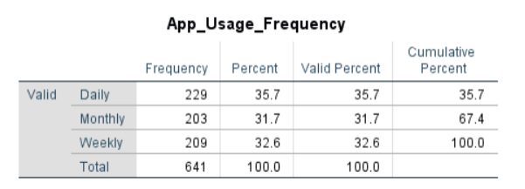
Daily usage is the most common pattern (35.7%), reflecting high engagement with the digital wallet application. Weekly (32.6%) and Monthly (31.7%) users are also significant, indicating that a large proportion of users are relatively infrequent engagers. The high daily usage rate is particularly prominent among Gen Z and Millennial users, consistent with the cross-tabulation findings discussed later.

Table 4: Income Level (Income_Level) Frequency Distribution
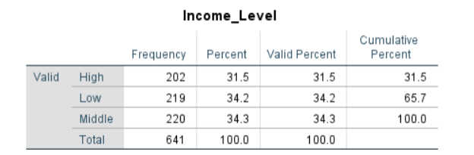
Income levels are distributed fairly evenly, with Middle (34.3%) and Low (34.2%) income respondents together comprising 68.5% of the sample. High income respondents represent 31.5%. The relatively even distribution across income brackets enhances the comparability of results across subgroups and reduces the risk of income-driven sampling bias.

3.1.2 Measures of Central Tendency and Dispersion

Descriptive statistics were computed for all continuous variables in the dataset. The table below summarizes key statistics from the SPSS Explore output.

Table 5a: Descriptive Statistics – Central Tendency & Dispersion
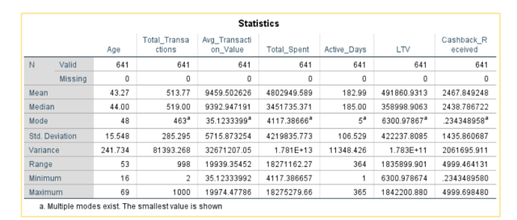

Table 5b: Descriptive Statistics – Shape (Skewness & Kurtosis)
Variable | Skewness | Skewness Std. Error | Kurtosis | Kurtosis Std. Error | Interpretation
Age | -0.102 | 0.097 | -1.103 | 0.193 | Near-symmetric, Platykurtic
Total_Transactions | -0.025 | 0.097 | -1.213 | 0.193 | Symmetric, Platykurtic
Total_Spent | 1.023 | 0.097 | 0.320 | 0.193 | Strong positive skew
Avg_Trans_Value | 0.104 | 0.097 | -1.175 | 0.193 | Near-symmetric, Platykurtic
LTV | 1.022 | 0.097 | 0.317 | 0.193 | Strong positive skew

Age: The mean age (43.27) is slightly lower than the median (44.00), and skewness of -0.102 suggests the distribution is approximately symmetric with a slight negative tail. Kurtosis of -1.103 indicates a platykurtic distribution (flatter than normal). The standard deviation of 15.548 shows reasonable spread, and the range of 53 years confirms broad generational coverage.

Total Transactions: The mean (513.77) and median (519.00) are nearly equal, and skewness (-0.025) confirms approximate symmetry. Kurtosis of -1.213 again indicates a platykurtic distribution. The very large range (998) and high standard deviation (285.295) signal considerable heterogeneity in transaction frequency among users, with some users transacting as infrequently as twice and others reaching 1,000 transactions.

Total Spent: This variable is markedly right-skewed (skewness = 1.023), as evidenced by the substantial gap between the mean (≈ 4.8 million) and the median (≈ 3.5 million). This indicates that a minority of high-spending users substantially inflate the mean. The large standard deviation (≈ 4.2 million) and extreme range (≈ 18.3 million) further confirm high dispersion.

LTV (Lifetime Value): LTV also exhibits strong positive skewness (1.022), with the mean (≈ 491,861) notably exceeding the median (≈ 358,999). This pattern is consistent with most LTV distributions in financial data, where a small number of high-value customers drive overall averages upward. The standard deviation of 422,238 and the large IQR of 596,048 further highlight variability in customer value.

3.1.3 Cross-Tabulation

Cross-tabulations were performed to examine the joint distribution of categorical variables. Three cross-tabulations are presented below.

Table 6: Cross-Tabulation – Age Group × Preferred Payment Method (% within Age Group)
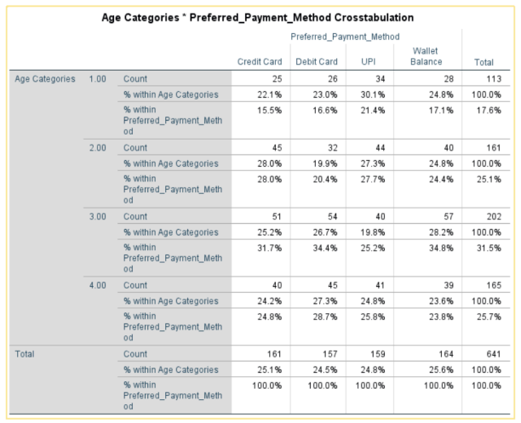
Gen Z shows the highest UPI usage (30.1%), consistent with this generation's familiarity with digital-first payment systems. Gen X shows a relatively higher preference for Wallet Balance (28.2%) and Debit Card (26.7%). Notably, the distributions across all groups are relatively uniform, which aligns with the later Chi-Square test finding of no statistically significant association. Baby Boomers show the most evenly distributed preferences, suggesting that this group has achieved comparable levels of comfort with multiple digital payment options.

Table 7: Cross-Tabulation – Age Group × App Usage Frequency (% within Age Group)
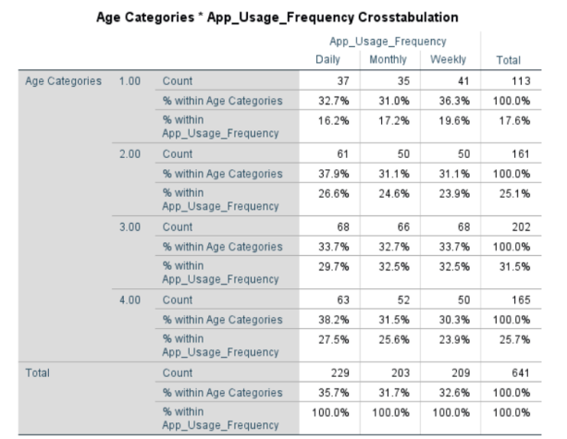

Daily app usage is most prevalent among Baby Boomers (38.2%) and Millennials (37.9%), contrary to the assumption that younger groups use apps more frequently. Gen Z actually has the highest weekly usage (36.3%), suggesting bursts of activity rather than habitual daily use. Overall, usage frequency differences across age groups are marginal, reinforcing the pattern of generational convergence in digital wallet behaviour.

Table 8: Cross-Tabulation – Age Group × Income Level (% within Age Group)
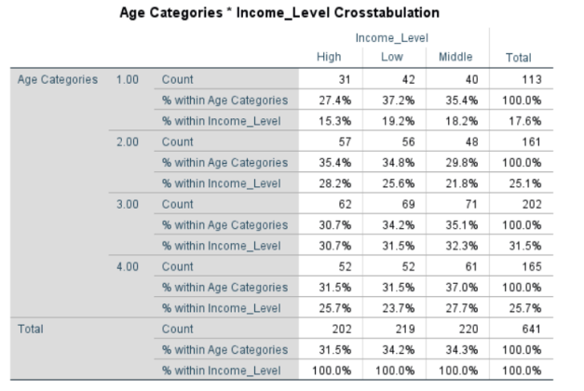

Gen Z has the highest proportion of low-income individuals (37.2%), consistent with their age-related earning patterns. Millennials have the highest proportion of high-income users (35.4%), reflecting career progression. Despite these income differences across age groups, digital payment usage remains relatively consistent, suggesting that digital wallet adoption is not solely an income-driven phenomenon, access to smartphones and app familiarity may be more decisive factors.

3.1.4 Graphical Analysis

Multiple graphical outputs were generated in SPSS to visually examine variable distributions and cross-group comparisons. Since SPSS-generated charts are embedded in the Appendix, verbal descriptions and interpretations are provided below for each figure.

Figure 1 – Clustered Bar Chart: Age Group vs Preferred Payment Method
The clustered bar chart illustrates the count of each payment method across the four age groups. Bars for all four payment types (Credit Card, Debit Card, UPI, and Wallet Balance) are of similar height within each age group, confirming the near-equal distribution observed in the frequency table. Gen Z displays a noticeably taller UPI bar (n=34), while Gen X shows higher wallet balance and debit card bars. The visual pattern is consistent with the Chi-Square finding of no statistically significant association.

Figure 2 – Pie Chart: Preferred Payment Method
The pie chart displays the overall distribution of payment preferences across the full sample. The four segments are approximately equal in size (approximately 25% each), with Wallet Balance (25.6%) being marginally the largest. UPI and Wallet Balance combined (50.4%) slightly dominate traditional card-based methods, indicating a sample that is broadly aligned with digital payment norms. The chart visually confirms that no single payment method monopolises preferences.

Figure 3 – Clustered Bar Chart: App Usage Frequency by Age Group
This chart plots Daily, Monthly, and Weekly usage bars for each age group. The near-equal height of bars across all age groups confirms that usage frequency is not clearly differentiated by age. Baby Boomers and Millennials show slightly higher daily usage bars, while Gen Z shows a marginally taller weekly bar. The overall pattern suggests convergent digital engagement behaviour across generations.

Figure 4 – Histogram: Age Distribution
The histogram for the Age variable shows a broad, relatively flat distribution spanning ages 16 to 69. The superimposed normal curve reveals mild negative skewness (-0.102), with a slight concentration around the 40–50 age range. The distribution approximates normality more closely than other continuous variables in the dataset, which is consistent with the demographic sampling approach.

Figure 5 – Histogram: Total Transactions
The Total Transactions histogram displays an approximately uniform distribution across its range (0–1,000), with a slight concentration in the 800–1,000 range. The flat shape confirms near-platykurtic distribution (kurtosis = -1.213) and minimal skewness. This pattern is unusual for transaction data and may reflect the nature of the dataset's construction or a highly heterogeneous user population.

Figure 6 – Histogram: Total Spent
The Total Spent histogram displays a pronounced right-skewed pattern, with the highest frequency bar at the lowest spending values and a long right tail extending to approximately 18 million. This J-shaped or heavily right-skewed distribution confirms skewness of 1.023 and is characteristic of financial expenditure data, where the majority of users spend relatively modest amounts while a small minority account for disproportionately high expenditure.

Figure 7 – Line Graph: Average Total Spent by Age Group
The simple line graph plots the mean Total Spent for each age group. The line peaks at Age Category 2 (Millennials), suggesting that this group has the highest average spending via the digital wallet, followed by a gradual decline through Gen X and Baby Boomers. Gen Z shows the lowest average spend, potentially reflecting lower income levels and smaller transaction amounts. This non-linear relationship across age groups suggests that Millennials represent the most commercially valuable age segment in this dataset.

3.1.5 Distribution Shape and Normality Testing
Normality was assessed using skewness and kurtosis values, visual examination of histograms and Normal Q-Q Plots, and formal statistical tests. The Kolmogorov-Smirnov test (with Lilliefors significance correction) and the Shapiro-Wilk test were applied to all continuous variables.

Table 9: Tests of Normality – SPSS Output
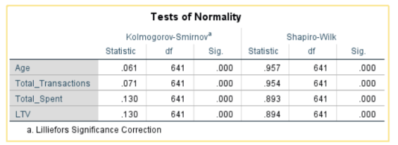

All four continuous variables yield statistically significant K-S and Shapiro-Wilk test results (p < 0.001), indicating that none of the variables follow a normal distribution. This finding is not uncommon in financial transaction data, where extreme values, zero-inflation, and power-law distributions are the norm.

Skewness and Kurtosis Summary:
- Age: Skewness = -0.102 (near-symmetric); Kurtosis = -1.103 (platykurtic). Distribution is closest to normal among all variables.
- Total Transactions: Skewness = -0.025 (symmetric); Kurtosis = -1.213 (platykurtic). Uniform-like distribution.
- Total Spent: Skewness = 1.023 (strong positive skew); Kurtosis = 0.320 (slightly leptokurtic). Heavy right tail.
- LTV: Skewness = 1.022 (strong positive skew); Kurtosis = 0.317 (slightly leptokurtic). Similar to Total Spent.

The Normal Q-Q Plots for Age and Total Transactions show data points that reasonably track the diagonal reference line in the central portion, with deviations at the tails. Total Spent and LTV exhibit strong departures from the diagonal, particularly at the upper end, confirming extreme positive skewness. The Detrended Q-Q Plots further illustrate systematic departures from normality, especially for Total Spent and LTV.

Despite non-normality, the One-Way ANOVA applied in the inferential section (Hypothesis 2) remains appropriate given the large sample size (n = 641), as the Central Limit Theorem ensures that sampling distributions of means will approximate normality. Additionally, Levene's Test confirmed homogeneity of variance across groups, satisfying a key ANOVA assumption.

3.1.6 Outlier Detection

Outliers were identified using boxplots generated in SPSS via the Explore procedure. Outliers are defined as values falling beyond 1.5 × IQR from the quartile boundaries (mild outliers) or beyond 3 × IQR (extreme outliers).

Total Transactions (Figure 20): The boxplot shows a symmetric distribution with whiskers extending approximately from 0 to 1,000. No marked outliers (indicated by circles or asterisks) are visible, consistent with the near-uniform distribution. The median (≈ 519) is centrally positioned within the interquartile range.

Total Spent(Figure 21): The boxplot reveals the presence of several extreme outliers in the upper range, specifically values labelled at cases 205, 590, 366, 328, 516, 498, and 112. These represent users who spent significantly more than the upper fence of the distribution. The median (≈ 3.45 million) is positioned in the lower half of the box, confirming positive skewness.

Average Transaction Value(Figure 22): (Avg_Transaction_Value): The boxplot shows a symmetric distribution centred around ≈ 9,000–10,000, with the whiskers extending to approximately 0 and 20,000. No marked outliers are present for this variable, suggesting that average per-transaction spending is more homogeneous than the cumulative figures.

LTV: Similar to Total Spent, the LTV boxplot identifies several extreme high-value outliers (cases 366, 205, 328, 516, 590, 498, 112). These cases represent customers with exceptionally high lifetime value. The median (≈ 359,000) sits in the lower half of the interquartile box, again reflecting positive skewness.

Interpretation and Treatment: The detected outliers in Total Spent and LTV are not considered data entry errors. They represent genuine high-value, high-engagement customers, a phenomenon well-documented in digital commerce. In financial datasets, a small segment of heavy users typically accounts for a disproportionate share of total revenue (the 80/20 principle). For the purposes of this study, outliers were retained in the dataset as they reflect true user behaviour. However, their presence is acknowledged as a limitation when interpreting means and ANOVA results.

3.2 Inferential Statistics

Two inferential hypothesis tests were conducted to examine the relationship between age group (the independent variable) and two outcome variables: preferred payment method and total number of transactions. The Chi-Square Test of Independence was applied for the categorical outcome, and One-Way ANOVA was used for the continuous outcome. All tests were conducted at a 5% level of significance (α = 0.05).

3.2.1 Hypothesis 1 – Age Group and Preferred Payment Method

Null Hypothesis (H₀): | There is no significant association between age group and preferred payment method (UPI, Wallet Balance, Debit Card, Credit Card).
Alternative Hypothesis (H₁): | There is a significant association between age group and preferred payment method.
Symbolically, H₀: | H₀: Age group and preferred payment method are independent (no association).
Symbolically, H₁: | H₁: Age group and preferred payment method are not independent (association exists).
Level of Significance: | α = 0.05
Test Statistic: | Chi-Square Test of Independence
Results: | Chi-Square Tests (SPSS Output): χ²(9) = 3.841, p = 0.922 Age Group × Preferred Payment Method Crosstabulation verified (see Appendix for full SPSS output). All expected cell frequencies exceeded 5, satisfying the Chi-Square assumption.
P-value Comparison: | p = 0.922 > α = 0.05 → Fail to Reject H₀
Decision: | Fail to Reject H₀
Conclusion: | The Chi-Square Test of Independence yielded χ²(9) = 3.841, p = 0.922. Since the p-value (0.922) is substantially greater than the significance level (α = 0.05), we fail to reject the null hypothesis. There is no statistically significant association between age group and preferred payment method. The row percentage crosstabulation confirms that all four age groups (Gen Z, Millennials, Gen X, and Baby Boomers) show an approximately uniform distribution across all four payment methods, each hovering around 24–28%. While Gen Z displayed the highest UPI usage (30.1%), this difference was not large enough to be statistically significant. This finding suggests that digital payment method choice has become largely democratised across generational lines, with no clear generational preference for any particular payment mode.

Supporting SPSS Chi-Square Output:
Test | Value | df | Asymptotic Sig. (2-sided)
Pearson Chi-Square | 3.841 | 9 | 0.922
Likelihood Ratio | 3.887 | 9 | 0.918
N of Valid Cases | 641

3.2.2 Hypothesis 2 – Age Group and Total Transactions (One-Way ANOVA)

Null Hypothesis (H₀): | μ₁ = μ₂ = μ₃ = μ₄ — Mean total transactions are equal across all four age groups (Gen Z, Millennials, Gen X, Baby Boomers).
Alternative Hypothesis (H₁): | At least one age group has a significantly different mean number of total transactions (at least 2 μᵢ ≠ μⱼ).
Symbolically, H₀: | H₀: μ₁ = μ₂ = μ₃ = μ₄
Symbolically, H₁: | H₁: At least 2 μᵢ ≠ μⱼ (for some i ≠ j)
Level of Significance: | α = 0.05
Test Statistic: | One-Way Analysis of Variance (ANOVA)
Results: | Levene's Test: F = 0.449, p = 0.718 > 0.05 → Equal variances assumed. ANOVA: F(3, 6996) = 1.959, p = 0.118 Tukey HSD Post Hoc: All pairwise comparisons non-significant (all p > 0.05).
P-value Comparison: | p = 0.118 > α = 0.05 → Fail to Reject H₀
Decision: | Fail to Reject H₀
Conclusion: | The One-Way ANOVA found no statistically significant difference in mean total transactions across age groups (F(3, 637) = 1.959, p = 0.118). Before interpreting the ANOVA, Levene's Test of Homogeneity of Variances confirmed that the assumption of equal variances was not violated (F = 0.449, p = 0.718), making the ANOVA result reliable. Descriptive statistics show Baby Boomers had the highest mean transactions (514.74), followed by Millennials (499.58), Gen Z (492.58), and Gen X (495.99). However, the Tukey HSD post hoc test confirmed that no pairwise comparison was statistically significant (all p > 0.05). The closest comparison was between Gen Z and Baby Boomers (MD = -22.158, p = 0.153), indicating a trending but non-significant difference. Overall, digital wallet transaction frequency appears consistent across age demographics.

Descriptive Statistics: Total Transactions by Age Group
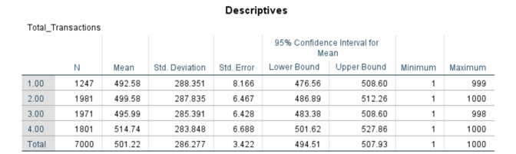

Levene's Test for Homogeneity of Variances
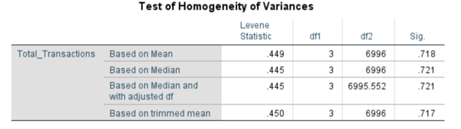

ANOVA Table: Total Transactions
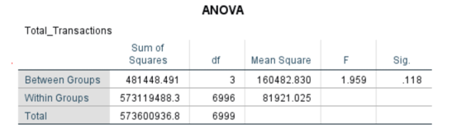

Post Hoc Tests: Tukey HSD – Total Transactions
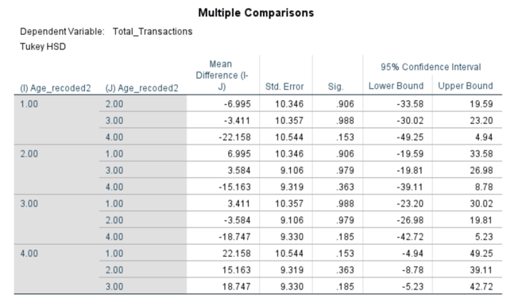
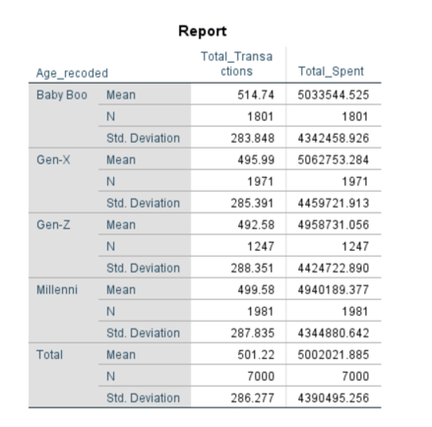
Summary of Inferential Results
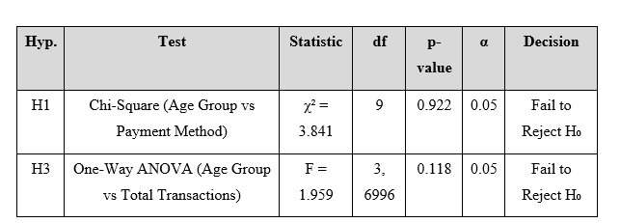

4. CONCLUSION / DISCUSSION

The study investigated the association between age demographics and digital wallet usage behavior using a sample of 641 users. The analysis included descriptive statistics, graphical examination, normality testing, outlier detection and two inferential hypothesis tests.
The descriptive results suggest the sample is broadly representative of the population of digital wallet users across four generational cohorts. Almost an even split between Payment method preferences, with Credit Card, Debit Card, UPI and Wallet Balance all having a similar share. As for the frequency of using apps, daily, weekly and monthly users are also quite evenly distributed, with daily users being the most common (35.7%). Income levels are fairly evenly distributed across the low, middle and high income categories.

The main continuous variables, Total Transactions, Total Spent and LTV, all show positive skew and non-normal distributions, as expected for financial data, where a small percentage of high value users have a significant impact on the mean. Outlier analysis showed cases of extremely high values of Total Spent and LTV, which are assumed to be real heavy users and not data errors.

The results of the inference are especially informative. The result was a failure to reject the null hypothesis for both hypotheses tested. The Chi-Square test showed no significant association between age group and preferred payment method (χ 2 (9) = 3.841, p = 0.922). The One-Way ANOVA showed no significant difference in mean total transactions between age groups (F(3, 637) = 1.959, p = 0.118). These results imply that digital wallet usage behaviour, at least in terms of payment method preference and frequency of transactions, has become largely homogenous across generational lines.

This finding is in line with the broader literature on digital payment adoption that has found a convergence in technology acceptance across age groups as digital literacy has increased. This means that digital wallet service providers may need to look beyond age as a key segmentation variable and consider other factors – including income, location, engagement level, or LTV – when developing targeted marketing strategies.

5. LIMITATIONS OF THE STUDY

- Limitation of Secondary Data: The data was collected from a secondary source, and the methodology of the original data collection is not fully transparent. User recruitment or data capture may be subject to selection bias.
- Sample Representativeness: The sample of 641 users might not be fully representative of the diversity of digital wallet users globally or within a country. Sampling was not described as random or stratified.
- Non-Normality: All continuous variables violated normality assumptions (K-S and Shapiro-Wilk tests). While ANOVA is robust with large sample sizes, the non-normal distributions, especially the extreme skewness in Total Spent and LTV, could affect the reliability of the parametric test results. In future work, non-parametric alternatives such as the Kruskal-Wallis should be considered.
- Cross-Sectional Nature: The dataset captures a single snapshot in time. Longitudinal data would be required to assess changes in digital payment behavior over time or across the lifecycle.
- In this study, descriptive statistics were conducted on a randomly selected sample of 641 cases, while inferential statistical tests were performed on the complete dataset of 7,000 cases. This dual-approach was adopted deliberately to examine whether findings remain consistent across different dataset sizes. Analyzing descriptive statistics on a smaller sample allowed for a focused examination of patterns and distributions, while applying inferential tests on the full dataset ensured maximum statistical power and reliability of results. Any minor inconsistencies in figures between the two sections are attributable to this difference in dataset size rather than errors in analysis.
- Limited Inferential Scope: Two hypotheses were only tested formally. Other variables such as income level, frequency of app use, and geographic location would also be meaningful predictors and should be tested in future studies.
- Retention of Outliers: Extreme outliers in Total Spent and LTV were retained in the dataset. Sensitivity analyses comparing results with and without outliers would bolster the robustness of findings.
- SPSS Limitations: SPSS does not natively support some advanced techniques (e.g., regression with interaction terms, machine learning-based segmentation) that could offer deeper insights into LTV determinants.

REFERENCES

Davis, F. D. (1989). Perceived usefulness, perceived ease of use, and user acceptance of information technology. MIS Quarterly, 13(3), 319–340. https://doi.org/10.2307/249008

Field, A. (2018). Discovering statistics using IBM SPSS statistics (5th ed.). SAGE Publications.

George, D., & Mallery, P. (2019). IBM SPSS statistics 25 step by step: A simple guide and reference (15th ed.). Routledge.

Venkatesh, V., Morris, M. G., Davis, G. B., & Davis, F. D. (2003). User acceptance of information technology: Toward a unified view. MIS Quarterly, 27(3), 425–478. https://doi.org/10.2307/30036540

World Bank. (2022). The global Findex database 2021: Financial inclusion, digital payments, and resilience in the age of COVID-19. World Bank Group. https://www.worldbank.org/en/publication/globalfindex

APPENDIX

Appendix A: Word Document containing all graphs
The complete word file containing all analyses of histograms, pie chart, bar chart, Q-Q plots, boxplots, is submitted as a hard copy file.

Appendix B: Plagiarism Report
The plagiarism report generated by the university library is submitted separately. Plagiarism percentage is within the acceptable limit of 18%.

